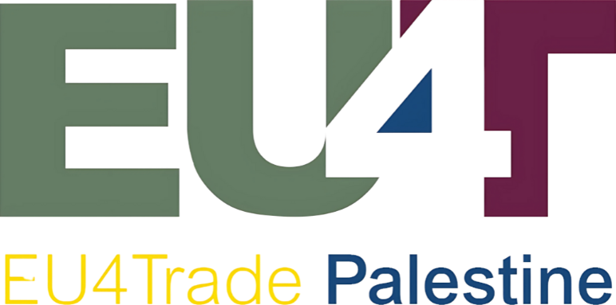

Press Release
PalTrade Launches the Market Intelligence Hub and the Rotterdam Logistics Hub: Two New Gateways for Palestinian Exports
Two Hubs, One Export Journey — from knowing your market to reaching it
For Immediate Release | Ramallah, 29 June 2026
The Palestine Trade Center (PalTrade) on Monday, 29 June 2026, launched the Market Intelligence Hub and the Rotterdam Logistics Hub at a ceremony in Ramallah. The two initiatives come under the EU-funded EU4Trade programme, in partnership with the Ministry of National Economy, and aim to strengthen the competitiveness of Palestinian exports and expand their access to European and international markets.
The Market Intelligence Hub provides Palestinian companies of all sizes with in-depth market data, analysis, and the regulatory requirements they need to enter EU and international markets — on the principle that information is the foundation of trade. The Rotterdam Logistics Hub gives Palestinian exporters a foothold at Europe’s largest port: by consolidating shipments from several exporters into full containers, it lowers freight costs and shortens delivery times, while providing storage, handling, and direct delivery of Palestinian products to buyers across the European market.
The launch brought together the Minister of National Economy, H.E. Mohammad Al-Amour; the Minister of Industry, H.E. Arafat Asfour; the Head of Cooperation at the European Union Representative Office, Mr. Mario Giuseppe Varrenti; and the Representative of the Kingdom of the Netherlands, Mr. Michel Rentenaar — alongside PalTrade Board Chairman Mr. Ibrahim Barham, CEO Ms. Ruwa Jabr, and representatives of the Palestinian private sector.
PalTrade Board Chairman Ibrahim Barham said the two hubs “represent a qualitative addition and a critically important step,” explaining that the Market Intelligence Hub platform gives Palestinian companies the in-depth information and analysis they need to reach markets, while the logistics platform in Rotterdam will help companies reduce the cost of shipping.
PalTrade CEO Ruwa Jabr said that “facilitating the work of exporting companies in Palestine is a central part of PalTrade’s mission,” pointing to the challenges of the recent period, including closures and the disruption of key crossings.
Minister of National Economy Mohammad Al-Amour said the two initiatives strengthen the ability of Palestinian companies to access accurate trade information and understand global market trends, adding that “trade — and export trade in particular — is a fundamental tool for economic development.”
Minister of Industry Arafat Asfour said that “today’s launch of the Rotterdam Logistics Hub reflects PalTrade’s ability to translate the real needs of the private sector into practical tools.”
“The launch of the Market Intelligence Hub and the Rotterdam Hub is an important step in strengthening Palestinian businesses’ competitiveness and access to international markets. By providing exporters with the knowledge, tools, and connections they need, we are investing in long-term economic resilience and sustainable growth. The European Union remains firmly committed to supporting the Palestinian economy and creating opportunities for a more prosperous future,” said EU Head of Cooperation Mario Giuseppe Varrenti.
“We strongly believe that strengthening Palestinian production, enhancing exports and actively accessing new international markets is necessary to overcome current challenges. It is the most viable path to lessen dependency on other markets and build independent economic strength. This is exactly where the Rotterdam and Market Intelligence Hub come in. They present a major opportunity for Palestinian exporters to overcome current trade restrictions, explore new markets, and significantly enhance the competitiveness of Palestinian products internationally,” said the Representative of the Kingdom of the Netherlands, Michel Rentenaar.
In the coming period, PalTrade will work with exporting companies to put both hubs to use — identifying export opportunities through the Market Intelligence Hub and planning consolidated shipments through the Rotterdam Logistics Hub. Companies can access the Market Intelligence Hub platform at mih-paltrade.org.
About PalTrade
The Palestine Trade Center (PalTrade) is a non-profit membership organization with 132 member companies across nine Palestinian governorates. As the national trade promotion organization, PalTrade supports Palestinian businesses in developing their exports and accessing international markets.
About EU4Trade
EU4Trade: Unleashing Palestine Export Potential to the EU and International Markets is a 36-month, EUR 3 million project funded by the European Union and implemented by PalTrade from July 2024 to July 2027, as part of the Team Europe Initiative supporting Palestinian private sector development.
Media Contact
Palestine Trade Center (PalTrade) Palestine Mall Building, 5th Floor, Al-Balou, Ramallah, Palestine Tel: +970 2 242 8383 Email: info@paltrade.org | Website: www.paltrade.org
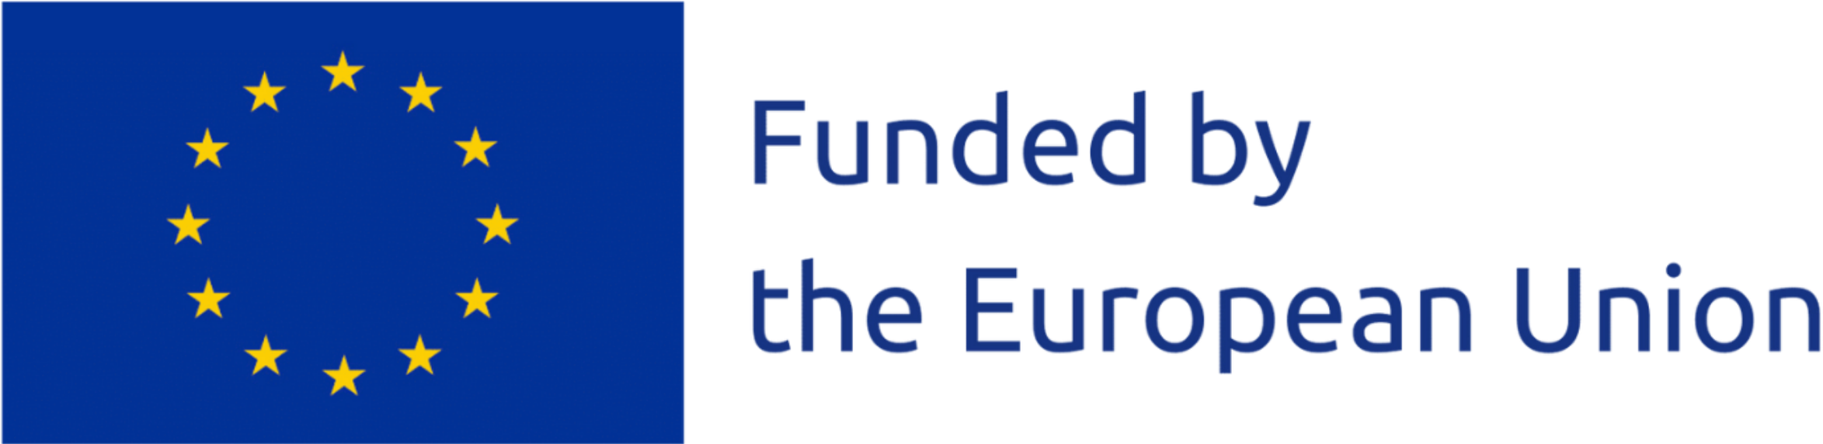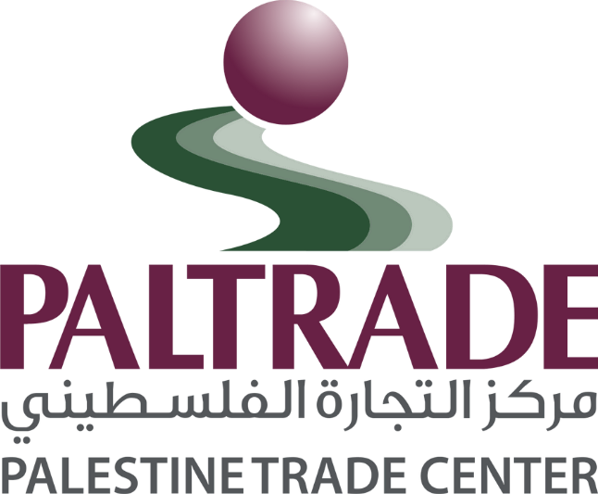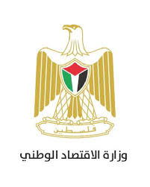
This content was produced with the financial assistance of the European Union. Its contents are the sole responsibility of Palestine Trade Center and do not necessarily reflect the views of the European Union.

